*Java Interview Question*

1.Why java is not 100% pure object oriented language?

-Because in java we have primitive data types namely: int, char ,boolean ,float, double, long ,short
-To make them object oriented we have wrapper classes which actually wrap the primitive data into an object of that class.
-Java is not a pure object-oriented programming language, because it has direct access to primitive data types. And these primitive data types don't directly belong to the Integer classes.

2.Why pointers are not allowed in java.
- Pointers are quite complicated and unsafe to use by beginner programmers
-Increases the complexity of the program and since java is known for its simplicity of code ,adding the concept of pointer will be contradicting.
-since JVM is responsible for implicit memory allocation ,thus in order to avoid direct access to memory by the user ,pointer are discouraged in java.

3.What is JIT compiler in java?
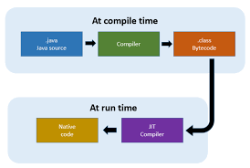
*Just-In-Time (JIT) Compilation in Java is a performance optimization technique used by the Java Virtual Machine (JVM) to improve the execution speed of Java applications.
-It works by compiling Java bytecode into native machine code at runtime, enabling faster execution.

WORKING : source code get converted into byte code using java compiler.
-The JVM interprets the bytecode line by line and convert bytecode to machine so it require lots of time to avoid this JIT compiler are introduced
- JIT compiles the bytecode into native machine code.

4.Why the string is immutable in Java?
-String pool requires string to be immutable otherwise shared reference can be changed from anywhere.
-For security like string is shared on different area like file system, networking connection, database connection, having immutable string allow you to be secure and safe because no one can change reference of string once it get created.

5.What is marker interface?
- A marker interface can be defined as the interface having no data member and member function. In simple terms ,an empty interface is called the marker interface.
e.g. serializable, cloneable
public interface cloneable{
}
-Its purpose is to provide run-time type information about objects, which allows the compiler and JVM to have more information about the object.

6.can you override a private or static keyword method in java?
-You can not override private or static method in java
-you can not override a private method in sub class because it’s not accessible there, what you do is create another private method with same name in child class.
-Static methods belong to the class rather than the instance of the class. As such, they are resolved at compile time using the reference type, not at runtime using the object type
-for static method if you create a similar method with same return type and same method argument in child class then it will hide the superclass method ,this is known as method hiding.

7.Does finally always executed in java?
- Not in cases
1.system. exit() function: when you explicitly called system.exit()
2. system. Crash

8.What methods does the object class have?
-object class is parent class of all object.
equals(): Compares two objects and returns true if they are equal
- finalize(): Called by the garbage collector when an object is removed from memory
- clone(): Creates a copy of the object
- toString(): Returns a string representation of the object
- hashCode(): Returns a numeric value for the object
- wait(): Makes the current thread wait for a notification from another thread
- notify(): Wakes up a single thread that is waiting for a notification from the object
- notifyAll(): Wakes up all threads that are waiting for a notification from the object
- getClass(): Returns the runtime class of the object
9.How can you make the class as immutable?
-declare the class as final so it can’t extended
-make all fields private so that direct access is not allowed
-make all the mutable fields as final so that it’s value can be assigned only once.
-initialize all the fields via a constuctor performing deep copy
-Don’t provide setter method for variables.
-perform cloning of object in the getter method to return a copy rather than returning actual object referance.
10.what is singleton class in java and how can we make class as singlton?
-singleton class is a class whose only one instance can be created at any given time ,in one JVM.
-public class Animal{
private static Animal single_instance=null; //need one object
private Animal(){} //nobody can access it
public static Animal getInstance(){
if(single_instance==null)
single_instance=new Animal();
return single_instance;
}}
-only one instance will be their.
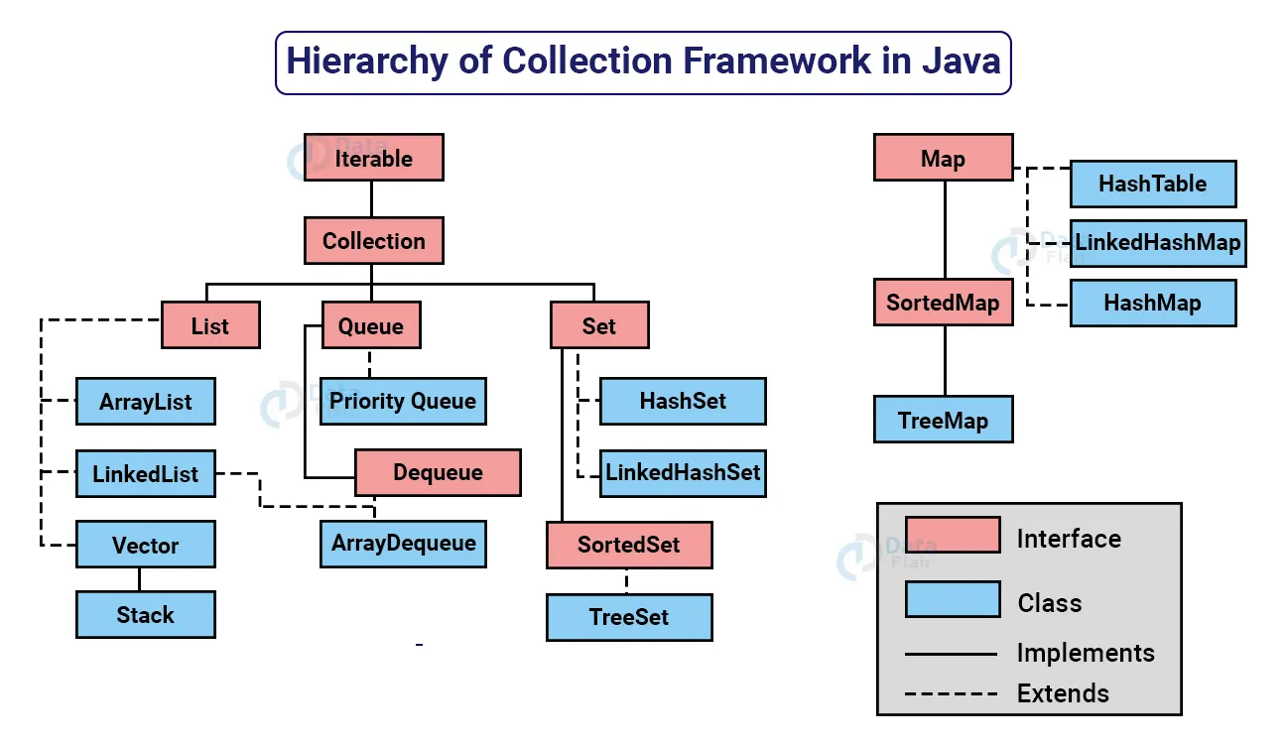
11.Explain collection hierarchy

- Java.util.collection is the root of java collection framework and most of the collections in java inherited from this interface except Map Interface.
-java.util.list:
- contain ordered elements
- may include duplicate,
- support the index-based search,
- random access but element can be easily inserted irrespectives of the position.
-java.util.set:
- doesn’t define an order for the element hence index based search is not supported
- doesn’t contain duplicate.
-java.util.queue:
- follows FIFO approach,
- element adds at rear end and
- remove from the front end.
-java.util.map:
- represent a key, value pair,
- map interface does not implement the collection,
- it can only contain a unique key,
- can have duplicate value

Classes:
1.Arraylist:
- Dynamic array; allows random access to elements.(50% of original size)
- non synchronized
2.LinkedList:
- Implements List and Deque interface
- maintain the insertion order
- Non Synchronized
- does not support accessing elements randomly
- can use ListIterator to iterate LinkedList element
3.Vector:
- vector is synchronized
- maintains the insertion oredr
- its thread safe
- vector increases its size by doubling the array size
- it is a legacy class
4.Stack:
- follow LIFO
- the element are added as well as removed from rear end
*Set :
1.Hashset:
- Its implicitly implements a hashtable
- contain only unique element
- only one null element can be added
- Its unordered as set
2.Linked Hashset:
- ordered version of hashset which maintains a doubly linked list across all elements.
- -it preserves the insertion order
3.Sorted set(interface):
- all element of sorted set must implement the comparable interface.
- It is a set sorted in an ascending order
4.Treeset:
- uses a tree for storage(self-balancing binary search tree like red-black tree)
- -objcet in a treeset are stored in sorted and ascending order.
*Queue:
priority queue:
- priority is a queue is a queue with priority associated with each element
- high priority element is served before a low priority element irrespective of their insertion order.
Deque:
- deque is doubly ended queue
- elements can be added and removed from either end.
ArrayDeque:(class)
- -way to apply resizable array in addition to the implementation of the deque interface no capacity restriction
*Map interface:
1.hashmap(class):
- it is non synchronized in nature
- allows only one null key but multiple null value
2.hashtable(class):
- It is synchronized in nature
- doesn’t allow any null key or value
*sorted map:
- entries are maintained in an ascending key order
- implicitly implements the red-black tree implementation
cannot store any null key
*difference between JDK, JRE, and JVM ?

*Why map doesn’t extend collection interface?
- The map interface in java follows a key/value pair structure whereas the collection interface is a collection of object which are stored in a structured manner with specified access mechanism.
- This is because they are not compatible. Collection requires an object as a parameter, but the map takes a key-value pair.
- Main reason map doesn’t extend collection interface is that the add(E e) method of the collection interface doesn’t support the key value pair like map interface’s put(k,v) method.
- This might not extend collection interface but still is an integral part of the java.

Why does Collection only extend Iterable and not Cloneable and Serializable?
This is because Serializable and Cloneable need not be extended because of their very specialized behavior.
*Differance between fail-fast and fail safe iterator?
-Fail-Fast iterators :
- immediately throw ConcurrentModificationException if there is structural modification of the collection.
- -Structural modification means adding, removing any element from collection while a thread is iterating over that collection.
- Iterator on ArrayList, HashMap classes are some examples of fail-fast Iterator.
- Fail-Safe:
- Fail-Safe iterators don’t throw any exceptions if a collection is structurally modified while iterating over it.
- This is because, they operate on the clone of the collection, not on the original collection and that’s why they are called fail-safe iterators.
- Iterator on CopyOnWriteArrayList, ConcurrentHashMap classes are examples of fail-safe Iterator.
*What do you understand by blockingqueue?
- BlockingQueue is a queue that additionally supports operations that wait for the queue to become non-empty when we are trying to retrieve an element,
- and wait for the space to be empty when an element is to be inserted in the queue.
- Java BlockingQueue implementations are thread-safe
*Differance between synchronized collection and concurrent collection?
-Synchronized Collection
- can be modified by one thread at a time.
- Synchronized Collection has low performance than Concurrent Collection because at a time only one thread is allowed to operate on an object so it increases the waiting time of the threads.
- Synchronized Collection acquires the lock on the entire Collection object which provides thread-safety.
- Whole segment is locked by this thread and other threads have to wait in synchronized collection.
Concurrent Collection :
- can be modified by multiple threads at a time(i.e. it is possible to modify or access Concurrent Collection by multiple threads simultaneously).
- Concurrent Collection has high performance than Synchronized Collection because at a time multiple threads are allowed to operate on an object so it decreases the waiting time of the threads.
- More than one threads can perform read-write operation concurrently still it provides Thread Safety.
- Only segment 1 is locked for read or write while all other 3 segments are open for other threads called lock stripping.

*Internal Working of HashMap?

- Internally, a HashMap uses an array of buckets or bins.
- Each bucket is a linked list of type Node, which is used to represent the key-value pair of the HashMap.
- When you add a key-value pair, the HashMap calculates a number (called a hash code) from the key.
- This hash code determines the index in an internal array where the pair will be stored.
- If two keys end up with the same index (collision), the HashMap stores them in a linked list at that index.
- To get a value using a key, the HashMap calculates the hash code, finds the index, and checks the linked list (if needed) to find the right key.
- If the key isn’t found, it returns null.
- If the HashMap gets too full, it resizes the array and moves all key-value pairs to the new array.

- Within the Linked List, the Inner Node class includes attributes such as a hash value, key, value, and a reference to the next node.
Let’s understand this with an example.
Imagine you have a big storage room with many shelves, each labeled with a unique number. Now, you want to store some items like books, shoes, and toys. Instead of randomly placing them on shelves, you use a special code for each item based on its type. For example, books might get a code like “B” and shoes “S” etc.
When you want to find a specific item later, you don’t need to search every shelf. You just generate the code you assigned to it. So, if you’re looking for a book, you know it’s on a shelf labeled “B”. This approach allows you to quickly locate what you require, bypassing the need to search through every shelf and saving valuable time.

*Is java pass by value or pass by reference?
-Java is strictly pass by value.
For primitives (e.g., int, float, boolean): The actual value is passed to the method. Changes made inside the method do not affect the original variable.
For objects: The reference (memory address) to the object is passed by value. This means the method gets a copy of the reference, so you can modify the object itself (since both references point to the same object). However, if you change the reference inside the method to point to a new object, it does not affect the original reference outside the method.

*Why is Java a platform independent language?
- Java language was developed so that it does not depend on any hardware or software because the compiler compiles the code(.java) and then converts it to platform-independent byte code(.class) which can be run on multiple systems.
- The only condition to run that byte code is for the machine to have a runtime environment (JRE) installed in it.

*3. Difference between Heap and Stack Memory in java. And how java utilizes this.
- Stack memory is the portion of memory that was assigned to every individual program. And it was fixed.
- On the other hand, Heap memory is the portion that was not allocated to the java program but it will be available for use by the java program when it is required, mostly during the runtime of the program.
*Java Utilizes this memory as -
- When we write a java program then all the variables, methods, etc are stored in the stack memory.
- And when we create any object in the java program then that object was created in the heap memory. And it was referenced from the stack memory.
- *Why are comparable and comparator interface introduced in java?

*differance between JDK,JRE and JVM?

JDK(Java Development Kit):
The JDK is a software development kit that provides the environment to develop and execute the java application. It includes two things:
- Development Tools (to provide an environment to develop your java programs)
- JRE (to execute your java program)

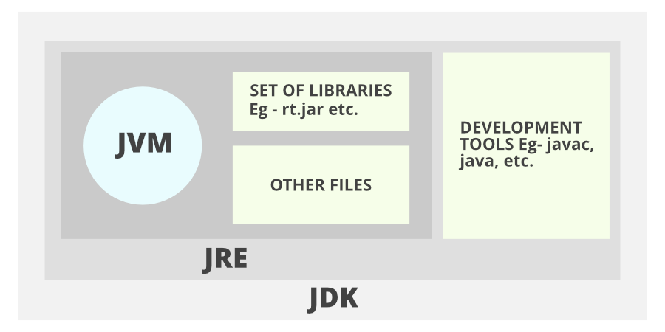

JRE((Java Runtime Environment)
- The JRE is an installation package that provides an environment to only run(not develop) the Java program (or application) onto your machine.
- JRE is only used by those who only want to run Java programs that are end-users of your system

JVM (Java Virtual Machine)
- The JVM is a very important part of both JDK and JRE because it is contained or inbuilt in both.
- Whatever Java program you run using JRE or JDK goes into JVM and JVM is responsible for executing the java program line by line, hence it is also known as an interpreter.

1.Comparable and comparator interface implementation?
2.Comparable and comparator differance?
3.Equals and hash code contract in java?
4.Is restricted access to derived method allowed?
5.Shadowing variable in java?
6.Association,Aggregation and Composition in java?
7.Covariant return types in java?
8.What is exception?
9.How do we handle exception in java?
10.Hierarchy of exception in java?
11.Difference between exception vs error?
12) Can we write only try block without catch and finally blocks?
13) Can we write any other statements between try catch or finally block?
14) Does remaining statements in try block executes after exception occurs.
15) What Is the Difference Between Throw and Throws Keywords in Exception Handling in java?.
16) What Happens When an Exception Is Thrown by the Main Method?
17) What do you understand by unreachable catch block error.
18) Type Promotions in java? Method overloading with type promotion?
19.type promotion rules in java,method overloading with type promotion in java,automatic type promotion in expressions in java
20.Why Java 8?Main agenda behind java 8?
21.Lambda Expression
22.What are main Advantages of using java 8?
23.What i slambda expression?
24.What is functional interface?
25.what are new features which got introduced in java 8?
26.How lambda expression and functional interface are related?
27.Can you create your own functional interface?
28.What is method reference in java 8?
29.What are defaults methods?
30. Is it necessary to override default methods of interface in java 8?
31.Is the default keyword one of the access modifiers?
32.How to override default methods?
33.Why Static methods were introduced in JAVA8
34.Are Static Methods available to implementing classes by default?
35.What are predicates?
36.How to use Predicates?
37.Type parameter and return types of Predicates?
38.Advantages of Predicates?
39.What is Predicate joining?
40.What are Functions
41.What is Functional chaining
42.what is consumer functional interface?
43.What is consumer chaining?
44.what is supplier functional interface?
45.what is consumer functional interface?
46.Advantages of supplier?
47.use of biconsumer,bifunction,bipredicate and why no bisupplier?
48.If we want to operate on 3 arguments then tripredicate?
49.What is stream?
50.Why streams were introduced in java 8 if we already had java.io.stream?
51.differance between streams (java 1.8) and java.io.stream?
52.differance between streams(java 1.8) and collection?
53.Step to create and process stream?
54.How to filter the strem object?
55.Steps to create and process stream?
56.How to map the stream objects?
57.Differance between filter and map?
58.How to map the stream object?
59.how to filter the stream object?
60.Steps to create and process stream?
61.Why do we need static and default methods?
62.Static method in interface?
63.why do we need static method?
64.Can we implement dynamic polymorphism with instance variables or data members
?
65.why default method in java 8?
66.Diamond/Ambiguity problem of multiple inheritance due to Default methods in Java 8
67.What do we need Design pattern-
68.categories java design pattern?
69.What are the Creational Patterns?
70.What Is Factory Pattern?
71.What Is Abstract Factory Pattern?
72.What Is Singleton Design Pattern?
73.What Is Builder Design Pattern?
74.What are Proxy Design Patterns?
75.Roles in Proxy Design Pattern?
76.Advantages of Proxy Design Pattern?
77.What is Flyweight Design Patterns?
78.Where to use Flyweight DP?
79.When to use Flyweight DP?
80.differance between final vs finally vs finalize in java?
81.differance between interface and abstract class?
82.can we overload main() method in java?
83.Why string is immutable and final in java?
84.can we override a static method in child class?
85.Different way of iterating an arraylist
86.
*Practical questions:
1.How to reverse a string
2.Remove junck/special chars in a string
3.how to reverse an integer
4.how to find missing number in array
5.how to fine duplicate element in java array?
6.largest and smallest number in array
7.string manipulation in java
8.swap two integers without using temp/third variable
9.swap two string without using temp/third variable
10.how to find primenumber
11.how to check pallindrome
12.how to find armstrong number
13.how to find factorial of number using recursive and non recursive
14.java program to count number of duplicate word
15.how to verify if the string contain only digit

*Springboot*
1.what is @SpringBoot?why did you use spring boot in your project?why not spring?
2.What RAD that you talking about ?how can you achieve RAD using springboot?
2.

